Original design

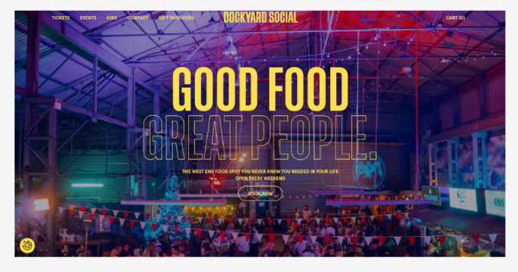

Modified design

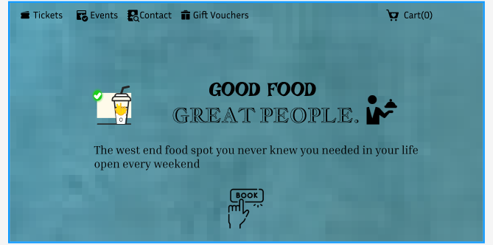

Visual Hierarchy & Readability

|  |
| --- |
| ✅ Clear structure with headers, subheaders, and body text. Font sizes and weights guide users’ eyes naturally. High contrast between text and background. |

|  |
| --- |
| ❌ Everything looks similar (same font size/color), making it hard to scan. Poor contrast (e.g., light gray text on white). Important elements don’t stand out. |

|  |
| --- |
| **Layout & Spacing** |

|  |
| --- |
|  |

|  |  |
| --- | --- |
| ✅ Thoughtful use of white space. Elements are grouped logically. Margins and paddings are consistent and generous, preventing clutter. | ❌ Overcrowded elements with little to no padding. Inconsistent spacing makes it look chaotic and hard to read. |

|  |
| --- |
|  |
| **Consistency & Alignment**   |  | | --- | | ✅ Consistent use of colors, fonts, button styles, and icons across all screens. Elements are neatly aligned to a grid. |  |  |  |  |  |  | | --- | --- | --- | --- | --- | | ❌ Random fonts, mismatched button styles, and misaligned elements. Inconsistent behavior (e.g., buttons that look the same but do different things).  Navigation   |  | | --- | | ✅ Simple, intuitive menus. Clearly labeled buttons. Breadcrumbs or back buttons present. Users always know where they are and how to go back. |  |  | | --- | | ❌ Confusing menus. Too many clicks to find something. No clear indicators of the current location. Inconsistent navigation patterns. |   Accessibility   |  |  | | --- | --- | | ✅ Supports keyboard navigation, screen readers. Sufficient color contrast. Text resizes properly. Icons have alt text. Focus states are visible. | ❌ No screen reader support. Low contrast. No keyboard nav. Missing labels or alt text. Hover-only features without fallbacks. | | | |

|  |
| --- |
|  |